EV MARKET SEGMENTATION ANALYSIS

The EV market segmentation helps understand the diverse landscape of electric vehicles. It categorizes EVs based on factors like vehicle type, range, price, and target audience. Segments include compact EVs for urban commuting, luxury EVs for affluent buyers, and long-range EVs for road trips. This segmentation assists manufacturers and consumers in making informed decisions, promoting the growth and development of the EV market.
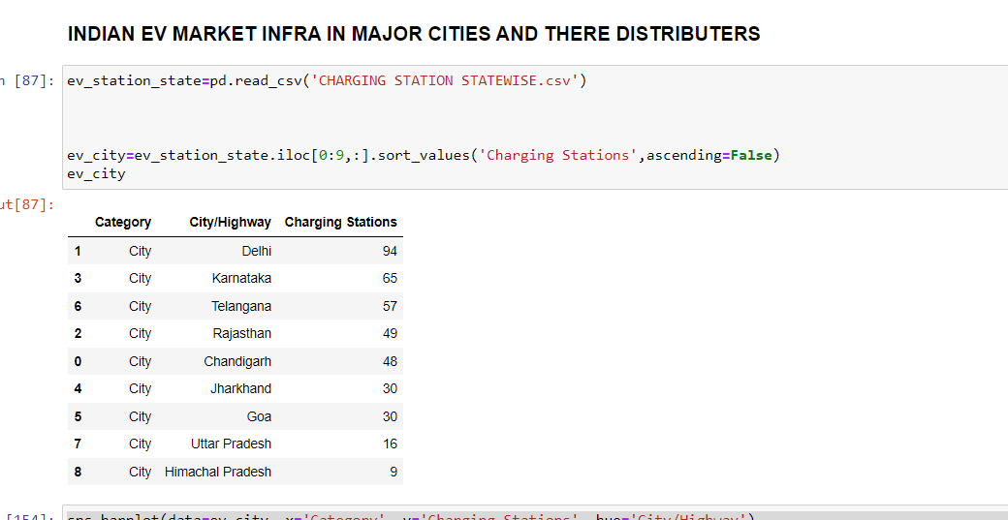

The spread of EV stations in India is gradually expanding, aiming to support the growing adoption of electric vehicles. Efforts from government initiatives, public-private partnerships, and corporate investments have led to an increase in charging infrastructure across major cities and highways. This expansion aims to enhance accessibility, convenience, and confidence in EV ownership, promoting a sustainable transportation ecosystem in the country

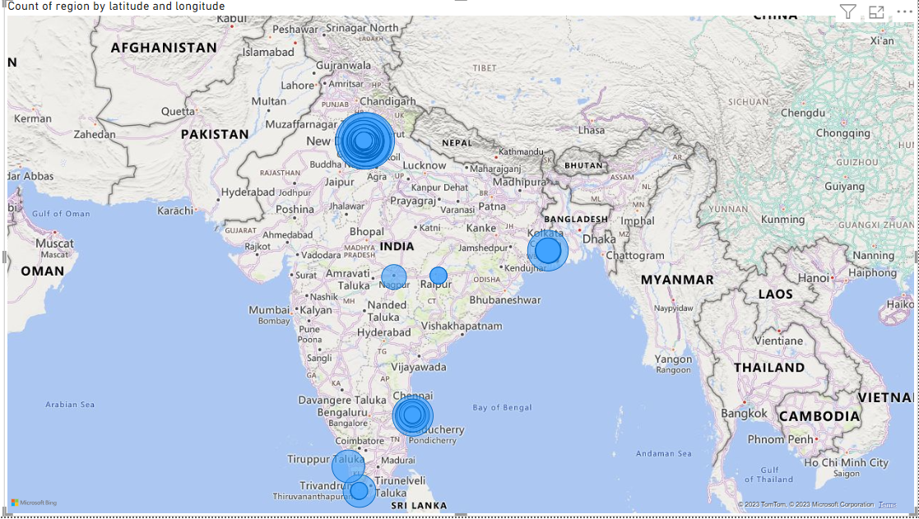

SPREAD OF CHARGING STATION IN INDIA -
- IN CITIES
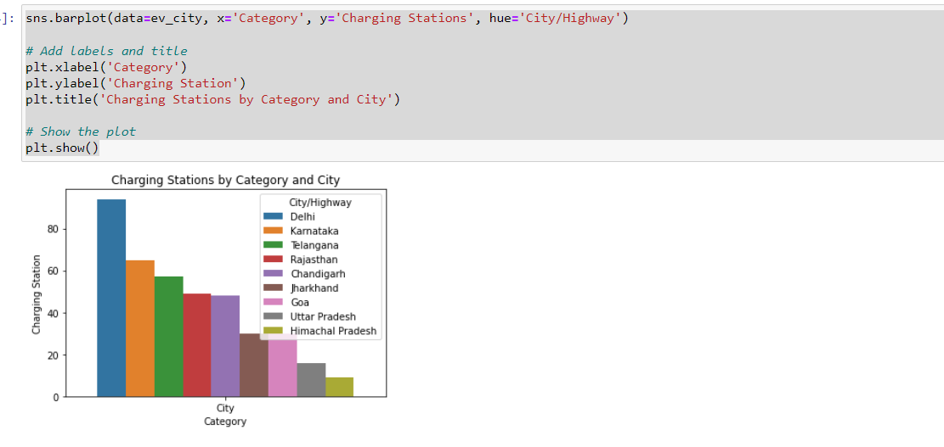
- ON HIGHWAYS
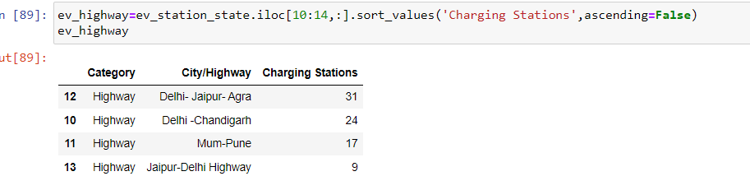

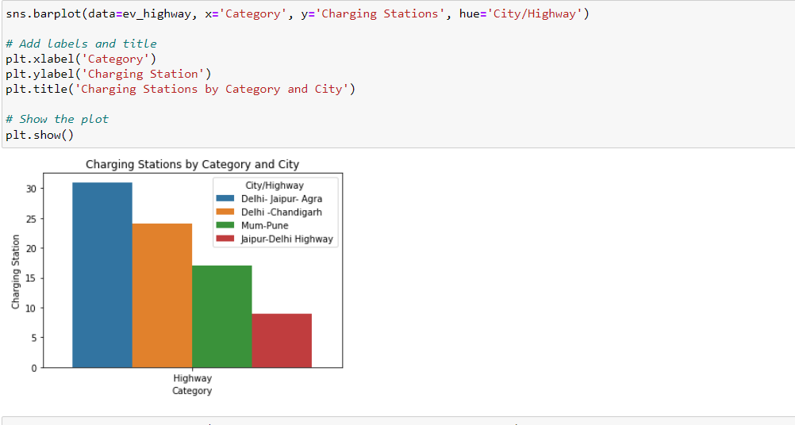
EV MARKET IN USA
The EV market in the USA has witnessed significant growth, with a rising number of electric vehicles on the roads. Major brands such as Tesla, Chevrolet, Nissan, Ford, and BMW have played a significant role in shaping the market. The availability of charging infrastructure, federal and state incentives, and increased consumer awareness have contributed to the widespread adoption of EVs in the country.
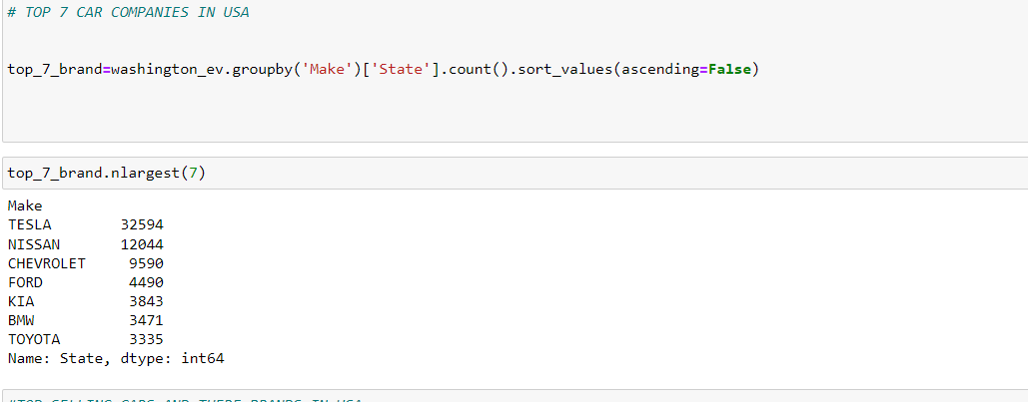
MARKET SHARE AND MOST SELLING CAR MODELS IN USA
TOP 10 CARS SOLD IN USA

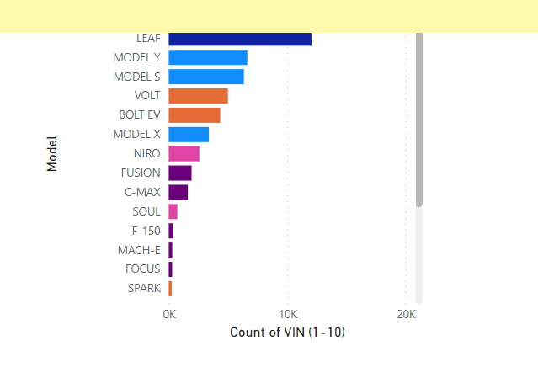
The EV market in the USA has reached a significant level of maturity, driven by advancements in technology, infrastructure development, and increasing consumer acceptance. The availability of a wide range of electric vehicle models, including sedans, SUVs, and even pickup trucks, demonstrates the market's progress.

Major automakers like Tesla, Chevrolet, Nissan, and Ford continue to expand their EV offerings, catering to diverse consumer needs. Additionally, the establishment of an extensive charging network, both at home and in public spaces, has alleviated range anxiety and boosted consumer confidence. Federal and state incentives, along with supportive policies, have further accelerated the growth of the EV market, making it a viable and sustainable transportation option for many Americans.
With continuous advancements and investments, the future of the EV market in the USA appears promising, with even greater adoption anticipated in the coming years.

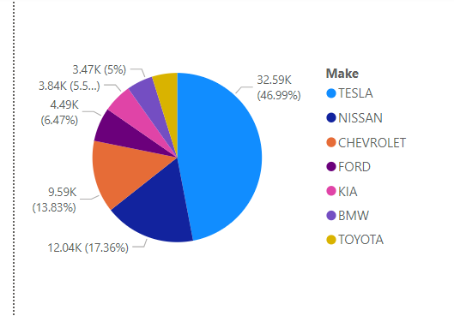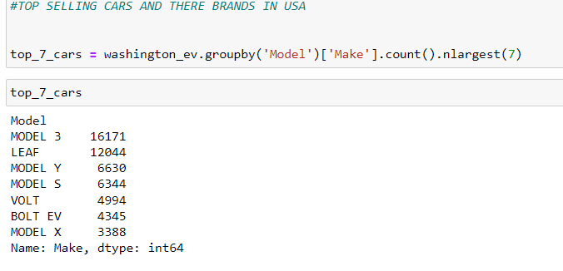
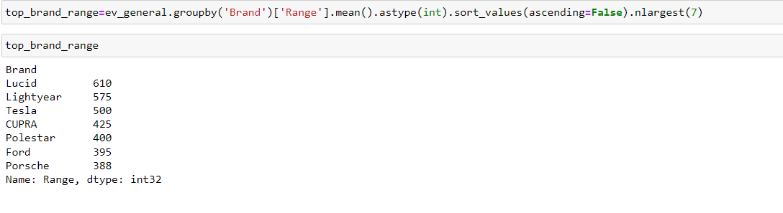

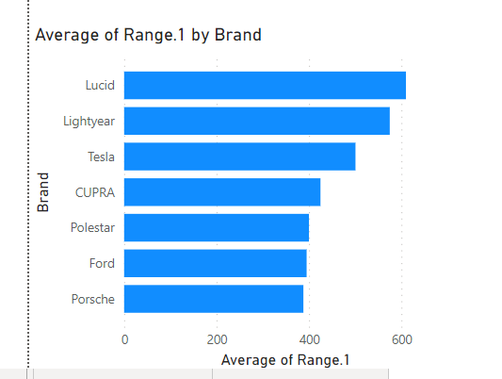

EV MARKET IN INDIA

The EV market in India is experiencing significant growth and transformation as the country strives to reduce emissions and promote sustainable transportation. Several major companies are actively participating in this market, including Tata Motors, Mahindra & Mahindra, Hero Electric, and MG Motor India. Tata Motors, for instance, has introduced electric models like the Tata Nexon EV and Tata Tigor EV, while Mahindra & Mahindra offers the Mahindra eVerito and Mahindra eKUV100. Hero Electric specializes in electric two-wheelers, and MG Motor India has launched the MG ZS EV.

Certain states in India have emerged as leaders in promoting and adopting EVs. Maharashtra, particularly Mumbai and Pune, has witnessed significant EV adoption due to favorable policies, incentives, and charging infrastructure development. Other states like Delhi, Karnataka, and Tamil Nadu have also taken notable steps to encourage EVs through policy support, subsidies, and infrastructure initiatives.

To further accelerate the growth of the EV market, the Indian government has implemented initiatives like the Faster Adoption and Manufacturing of Hybrid and Electric Vehicles (FAME) scheme. FAME provides financial incentives to both consumers and manufacturers, promoting the adoption of EVs across the country.

With increasing awareness, government support, and technological advancements, the EV market in India is poised for significant expansion, making electric mobility a crucial component of the country's transportation landscape.



CHART FOR TOTAL COUNT OF EV VS CONVENTIONAL VEHICLE

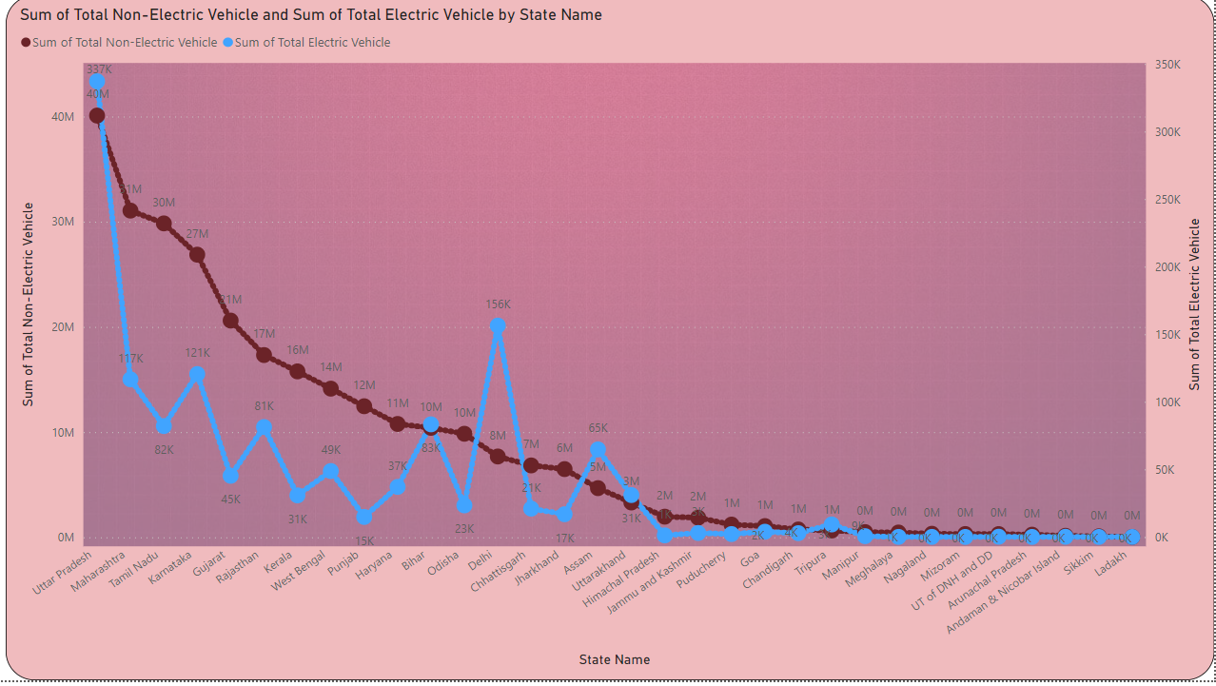

As of my knowledge cutoff in September 2021, I can provide a summary of passenger vehicle data in Indian states based on historical information. However, please note that the data might have changed since then. Here is a general summary:
Maharashtra: Maharashtra has a high number of passenger vehicles and is home to major automotive manufacturing hubs like Mumbai and Pune.
Uttar Pradesh: Uttar Pradesh has a significant population and thus a considerable number of passenger vehicles.
Tamil Nadu: Tamil Nadu is another state with a substantial presence in the automotive industry, housing manufacturing facilities for various automobile companies.
Karnataka: Karnataka, specifically Bengaluru, has a significant number of passenger vehicles due to its status as a major IT hub.
Gujarat: Gujarat has witnessed rapid industrialization and has attracted automotive manufacturing investments, resulting in a notable number of passenger vehicles.
Delhi: Being the capital city, Delhi has a large number of passenger vehicles despite challenges related to pollution and traffic congestion.
Rajasthan, Andhra Pradesh, Telangana, Kerala, and other states also have a considerable number of passenger vehicles .

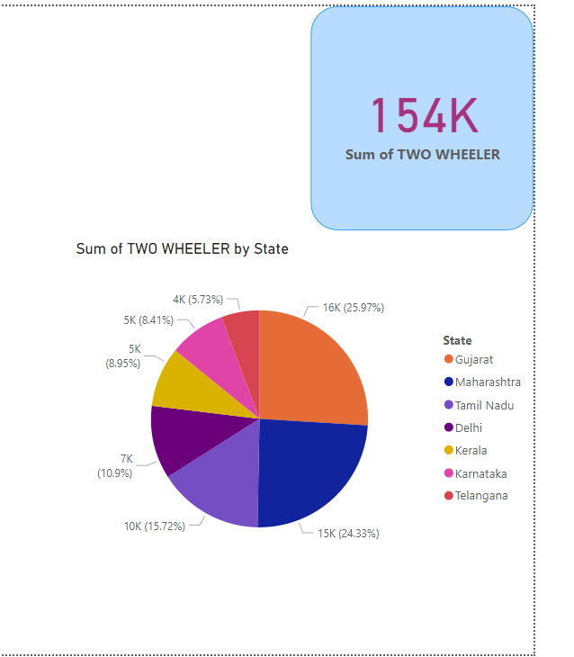

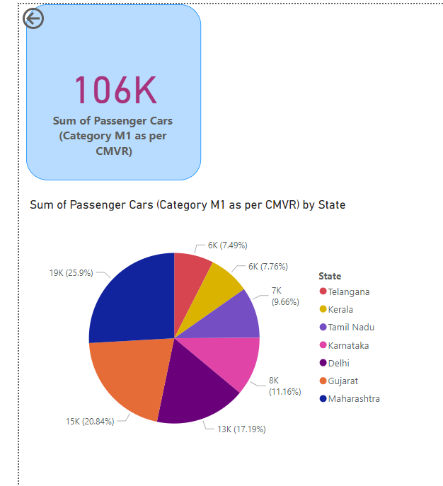

SUMMARY OF POLLUTION IN INDIA
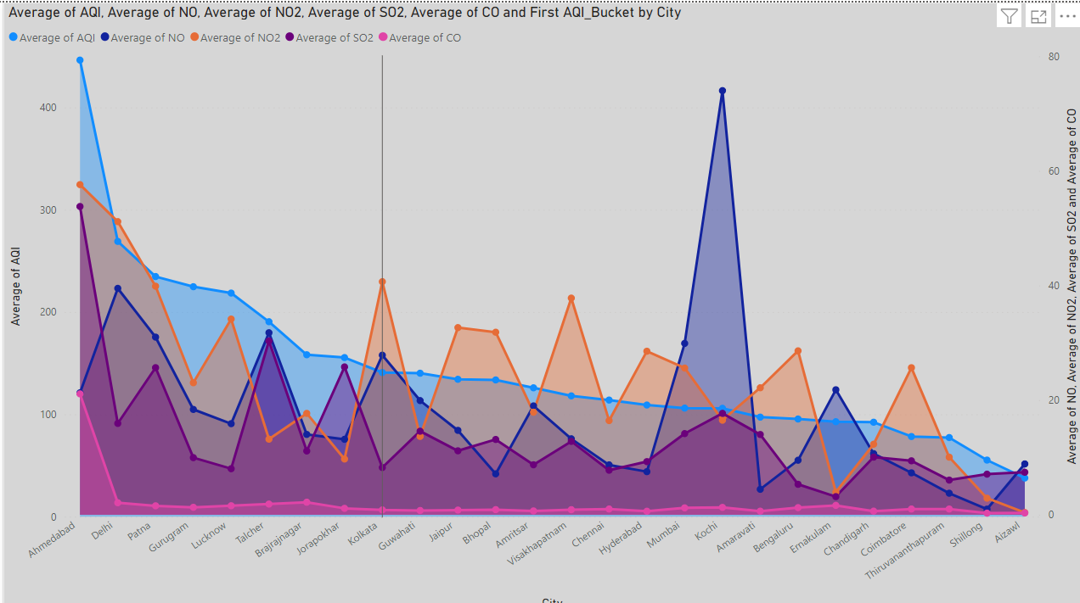

The increasing pollution in India can potentially contribute to the increase in the sale of electric vehicles (EVs) for several reasons:
1. Environmental Awareness: Rising pollution levels in cities have led to increased awareness about the detrimental effects of traditional gasoline and diesel vehicles on air quality. This awareness can drive individuals to consider cleaner alternatives like EVs.
2. Government Incentives: The Indian government has implemented various policies and incentives to promote the adoption of EVs. These include subsidies, tax benefits, and reduced registration fees, making EVs more financially attractive to potential buyers.
3. Improved Infrastructure: The need to combat pollution has led to the development of charging infrastructure in major cities. Increased availability of charging stations provides convenience and addresses concerns about range anxiety, making EVs a more viable option.
4. Stringent Emission Standards: The Indian government has set increasingly stringent emission standards for vehicles. To comply with these regulations, automakers are encouraged to introduce more electric and hybrid vehicles into the market.
5. Public Transport Transition: Government initiatives to electrify public transportation, such as buses and taxis, help create a visible shift towards EVs. This transition can inspire confidence in the technology and encourage private individuals to consider EVs for personal use.
6. Technological Advancements: As EV technology advances, concerns about limited range and charging times are being addressed. Improved battery technology and longer driving ranges make EVs more practical for everyday use.
While the increasing pollution levels in India are a concerning issue, it has also acted as a catalyst for the growth of the EV market. The combination of environmental consciousness, government support, infrastructure development, and technological advancements is driving the shift towards electric mobility and contributing to the increased sale of EVs in India.






